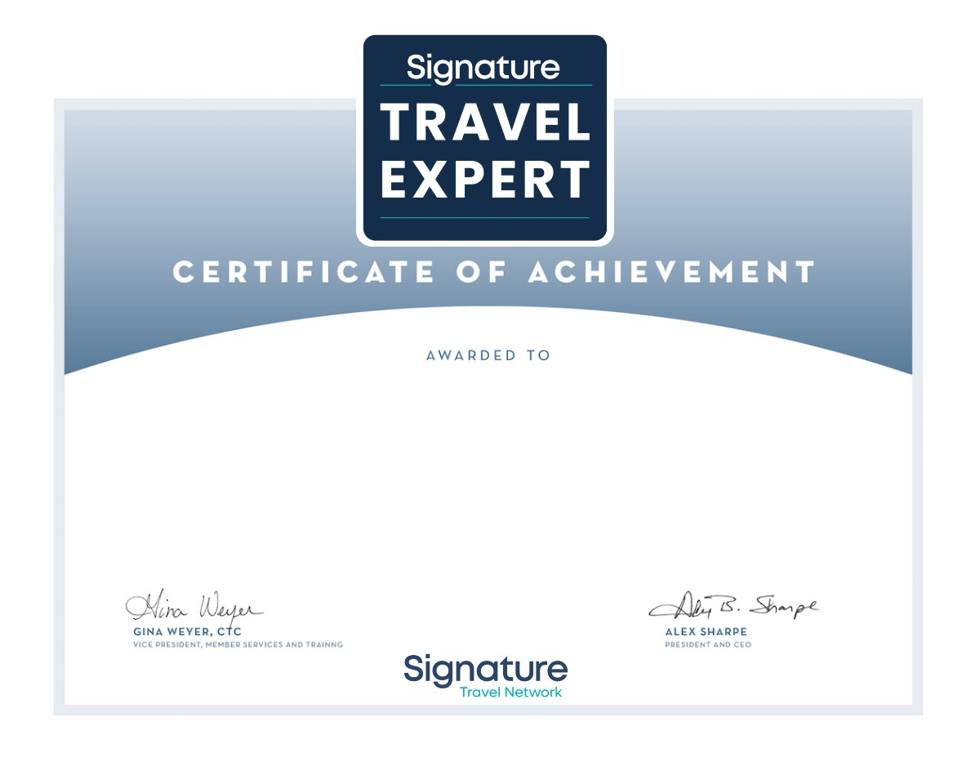

Cherise Isbell

In recognition of certification as a Signature Travel Expert

October 19, 2023